Wesportal IRB Protocol Submission Instructions

Contents
Accessing the Institutional Review Board Application…………………………………………………………………….2
New Submissions……………………………………………………………………………………………………………………………3
Viewing Submissions………………………………………………………………………………………………………………………5
Student Submission………………………………………………………………………………………………………………………..7

Accessing the Institutional Review Board Application
To access the new IRB submission app, go to WesPortal and, under Academics, click the link called Institutional Review Board.
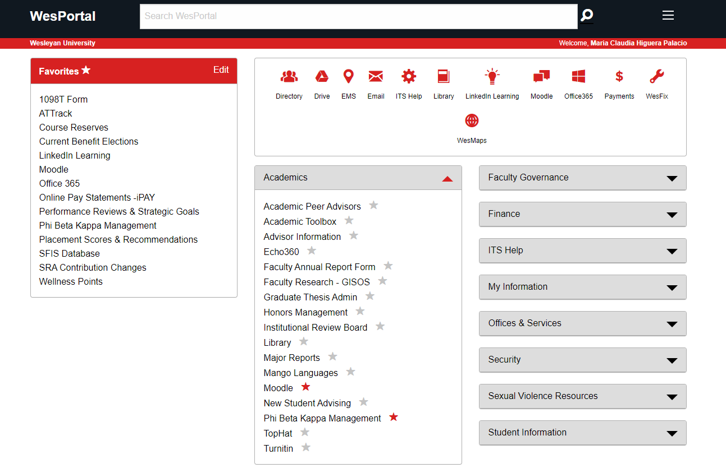

New Submission
When you open the IRB app, you will see a page where you can submit a new application (“New Submission”). The first step is to download the Description of Research Form, a MS Word document, from the IRB web site (https://www.wesleyan.edu/acaf/support/reviewboard.html). Complete the form, and save it to a computer or network folder. In the IRB app, file in the Title, Short Title, and “Short Project Description” boxes.

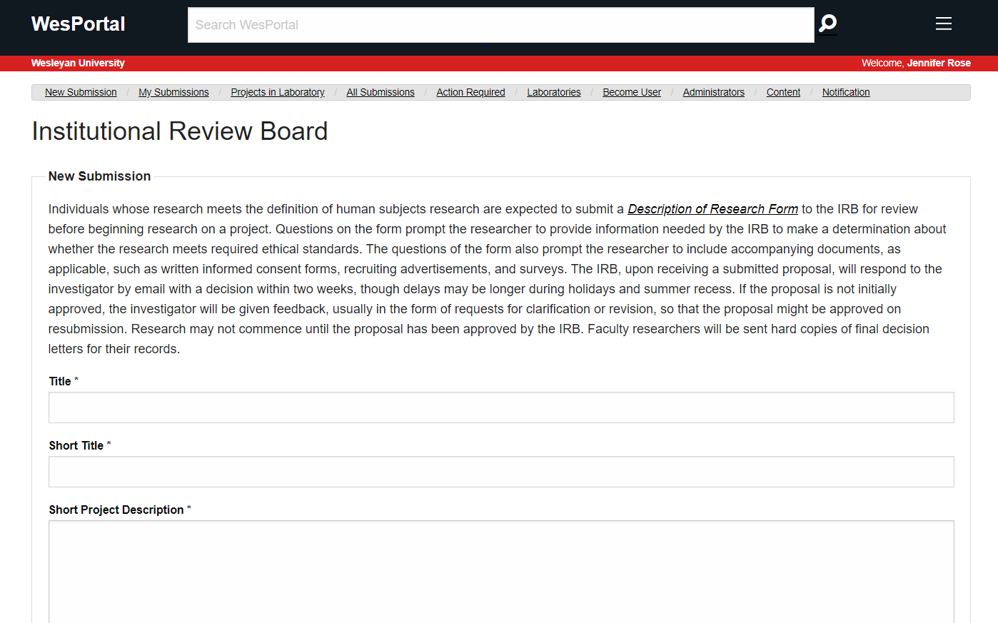

Then scroll down to Documents. Upload your completed Description of Research Form under “Description of Research”. Then, upload your consent form (a template can be found on the IRB web site), a Video Release Form (also on the IRB web site), if applicable, and any supplemental files. After uploading your files, click the red “Submit” button.
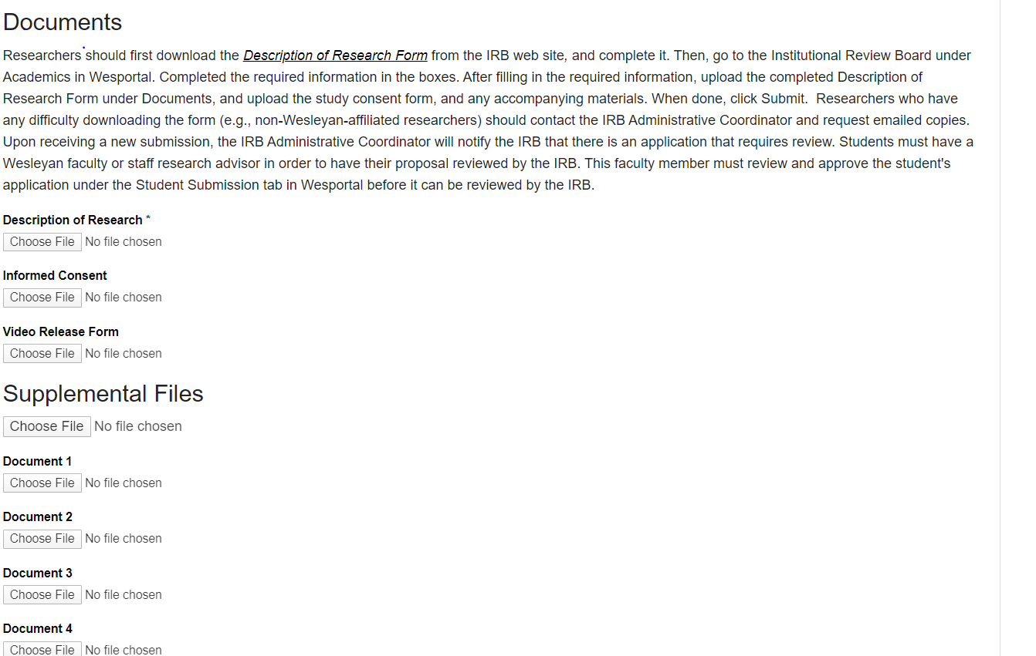

Viewing Submissions
To view all your submitted IRB protocols, click “My Submissions”.
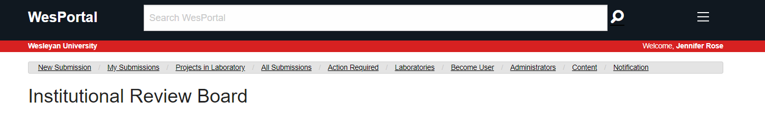
Under My Submissions, you will see 2 tabs (Student Submission and My Submission). Click on My Submission. Here you will see a list of IRB protocols and the current approval status of those protocols.
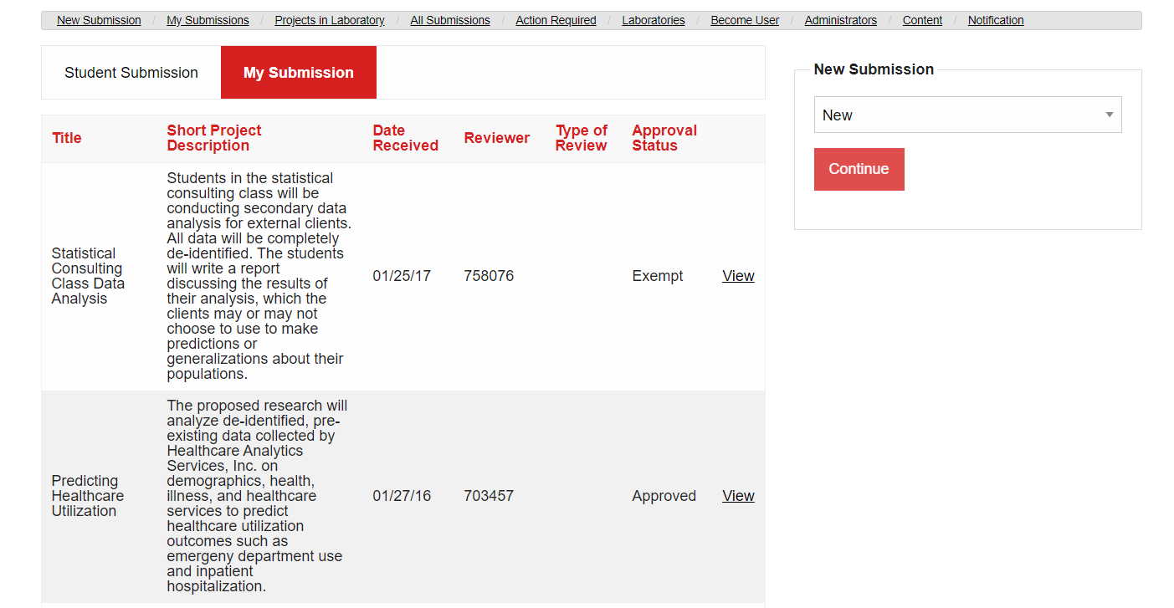

If you click on View, you will see more details about that IRB protocol, as well as a list of documents associated with that protocol. On the right hand side under New Submission, there is a menu from which you can choose a number of actions: New (to submit a new Description of Research Form), Request of Renewal (to submit a completed Project Continuation Form), Project Update (to submit a completed Project Update Form), and Change of Protocol (to submit a completed Change of Protocol Form). After choosing one of the menu options, you will be prompted to choose the IRB protocol on which you would like to take action.
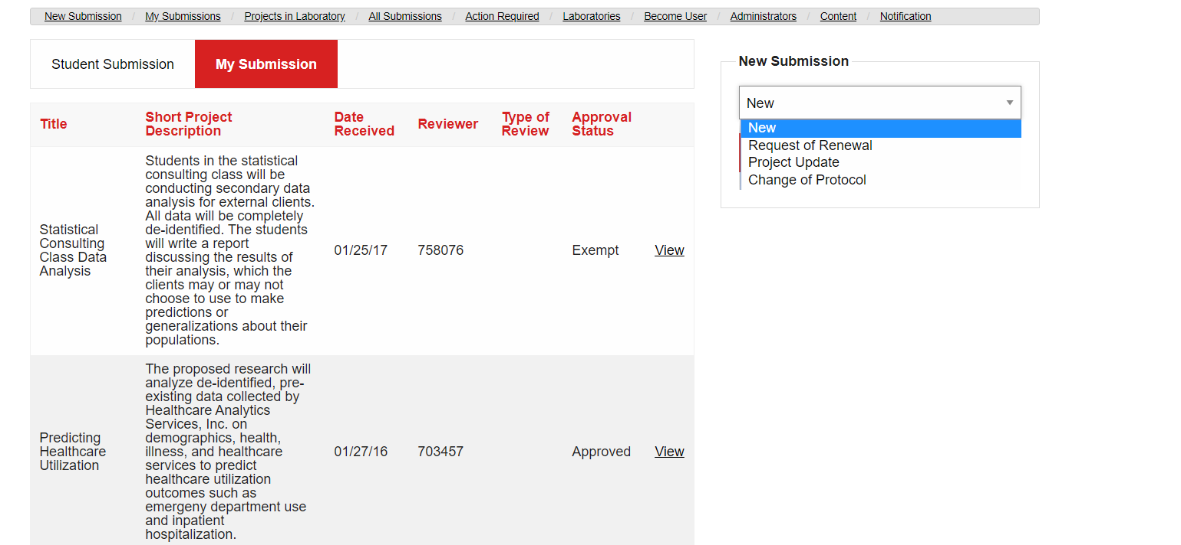
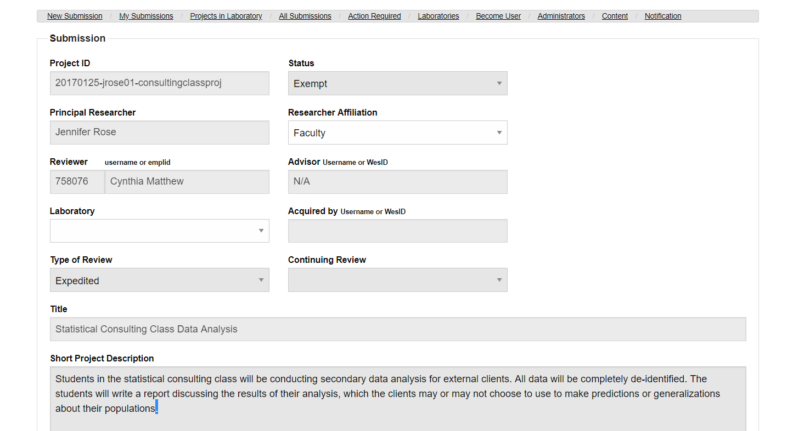

If you scroll down, you can see where you can upload new forms and supplemental files. After you upload the completed forms, scroll down and click the red Save button. This will notify the IRB that a change has been made that requires the IRB to take action.

Student Submission – Faculty Only
If you click on Student Submission, you will see a list of the student IRB projects for which you are listed as the advisor. Here you can view and approve the student protocol. The IRB will not review a student submission without advisor approval.

